**Create two storage accounts and containers or objects with files in it and move files between them in your preferred cloud.**

**Login to AWS console and click on create bucket**

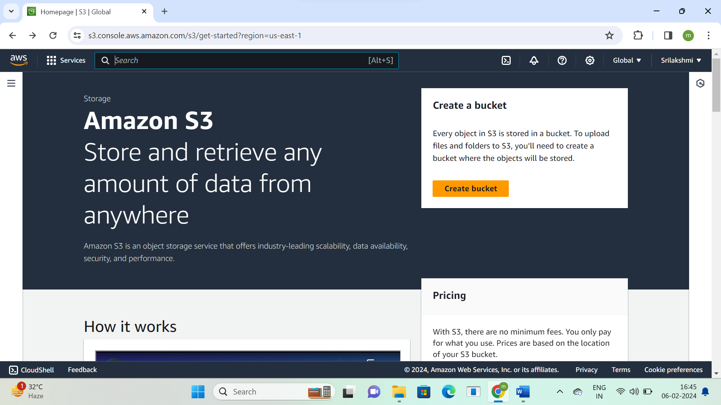

**Create 2 S3 buckets**

**1st S3 bucket name- sribuckett1**

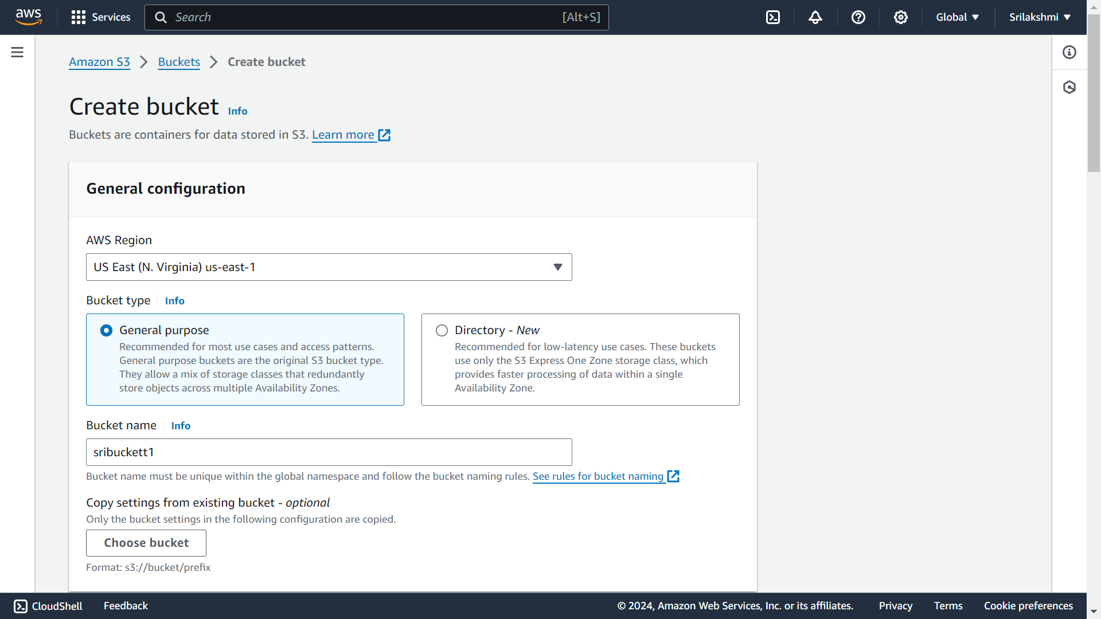

**2ndS3 bucket name-sribuckett2**

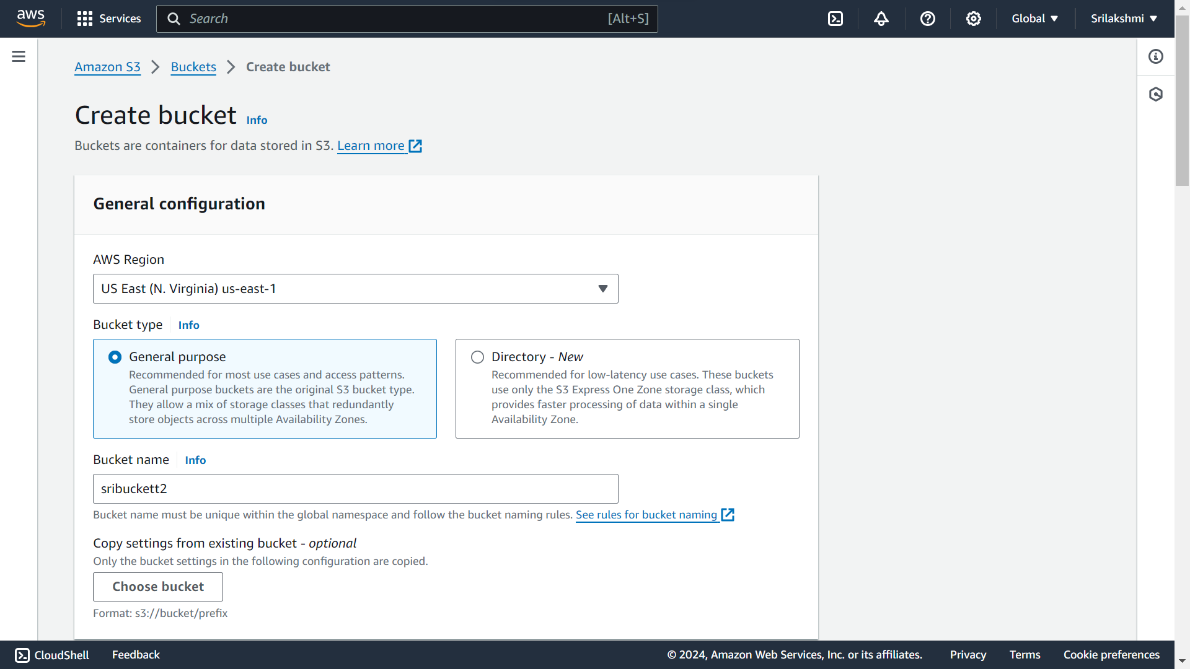

**These are the created 2 S3 buckets, now click on 1st S3 bucket-sribuckett1 and upload the file**

**Next click on 2st S3 bucket-sribuckett2 and upload another different file**

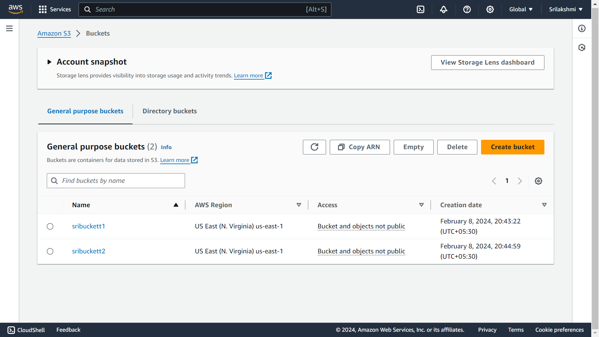

**Go to 1st S3 bucket-sribuckett1, click on upload and upload the file**

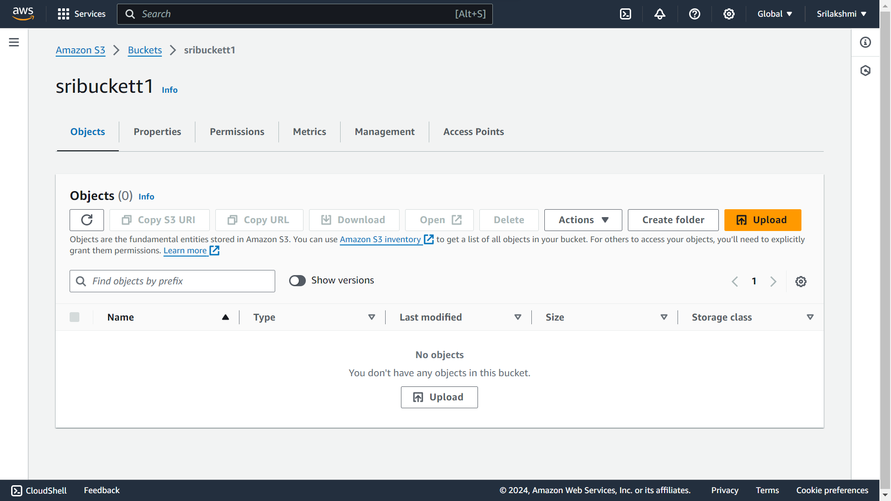

**This is the uploaded file in 1st bucket-sribuckett1**

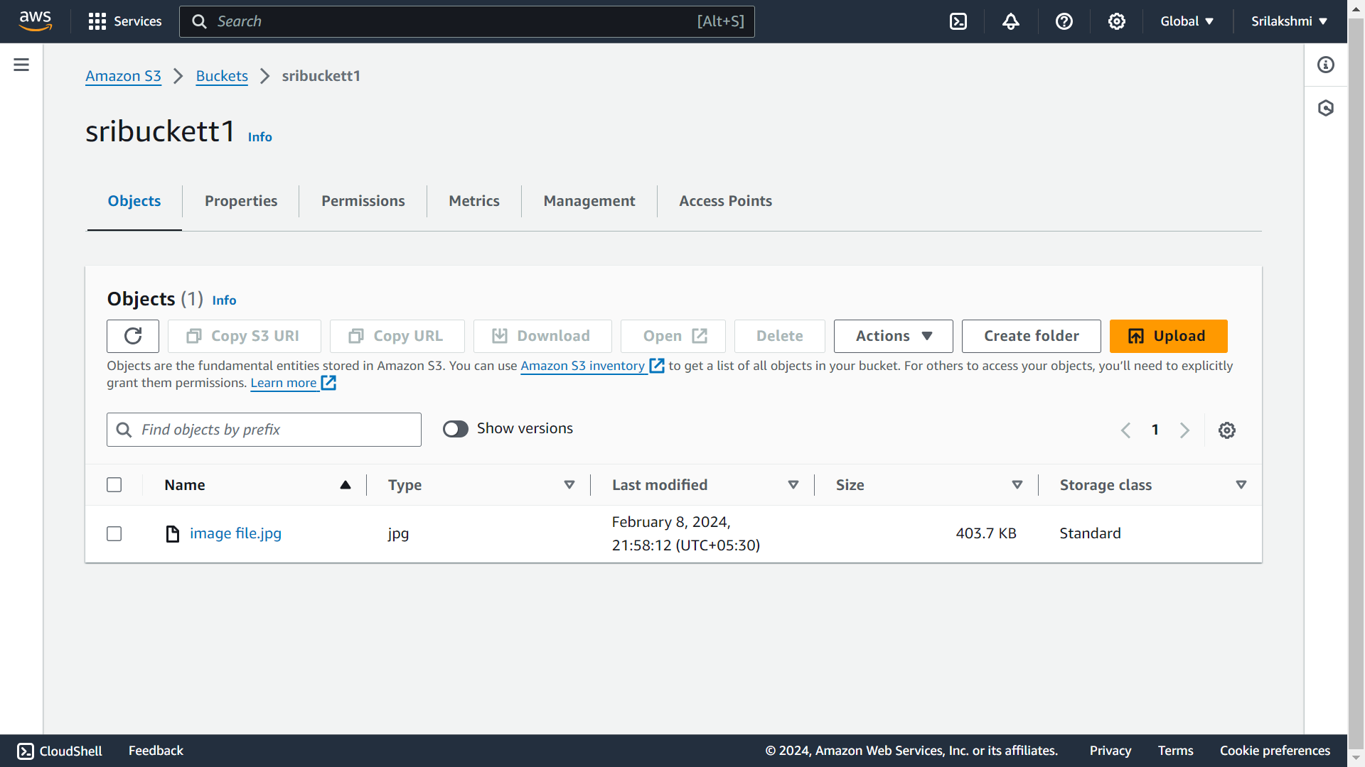

**This is the uploaded file in 2nd bucket-sribuckett2**

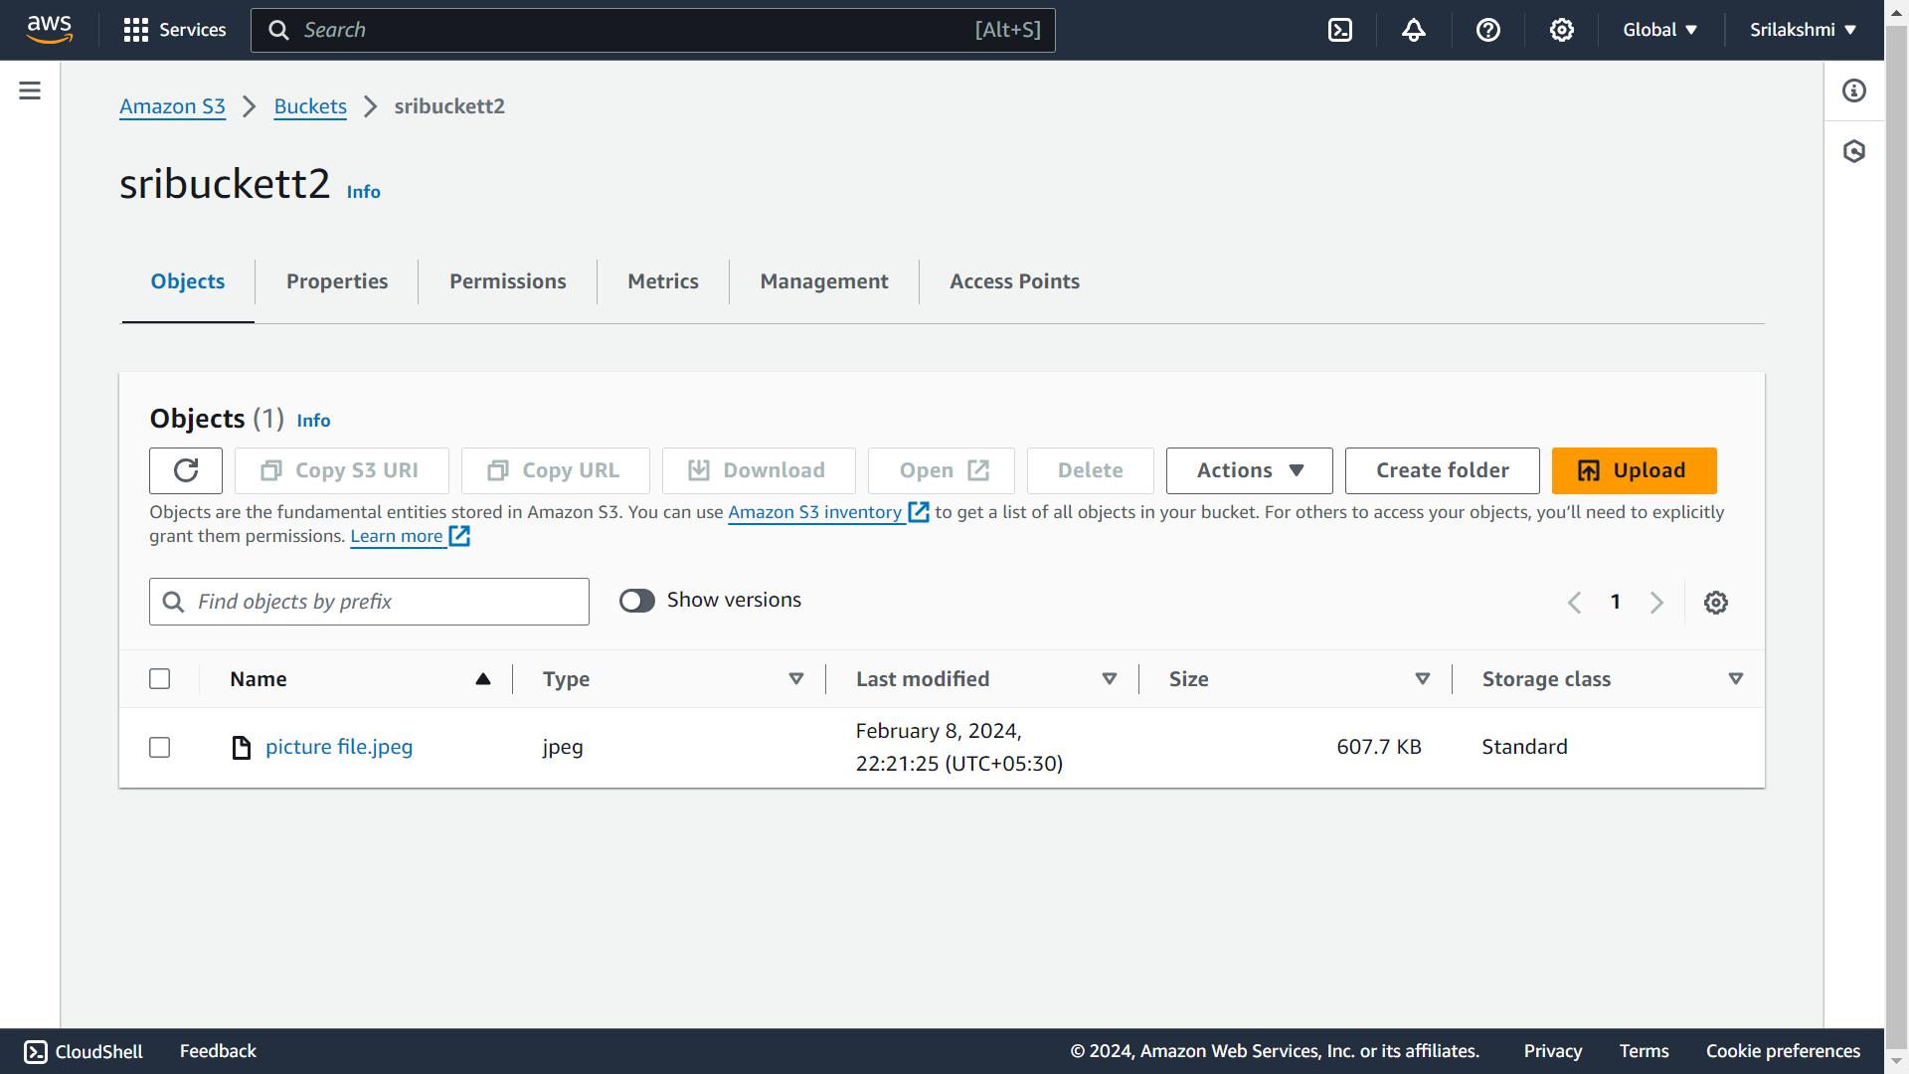 **Select the 1st S3 bucket-sribuckett1 uploaded file and go to actions and click on move option**

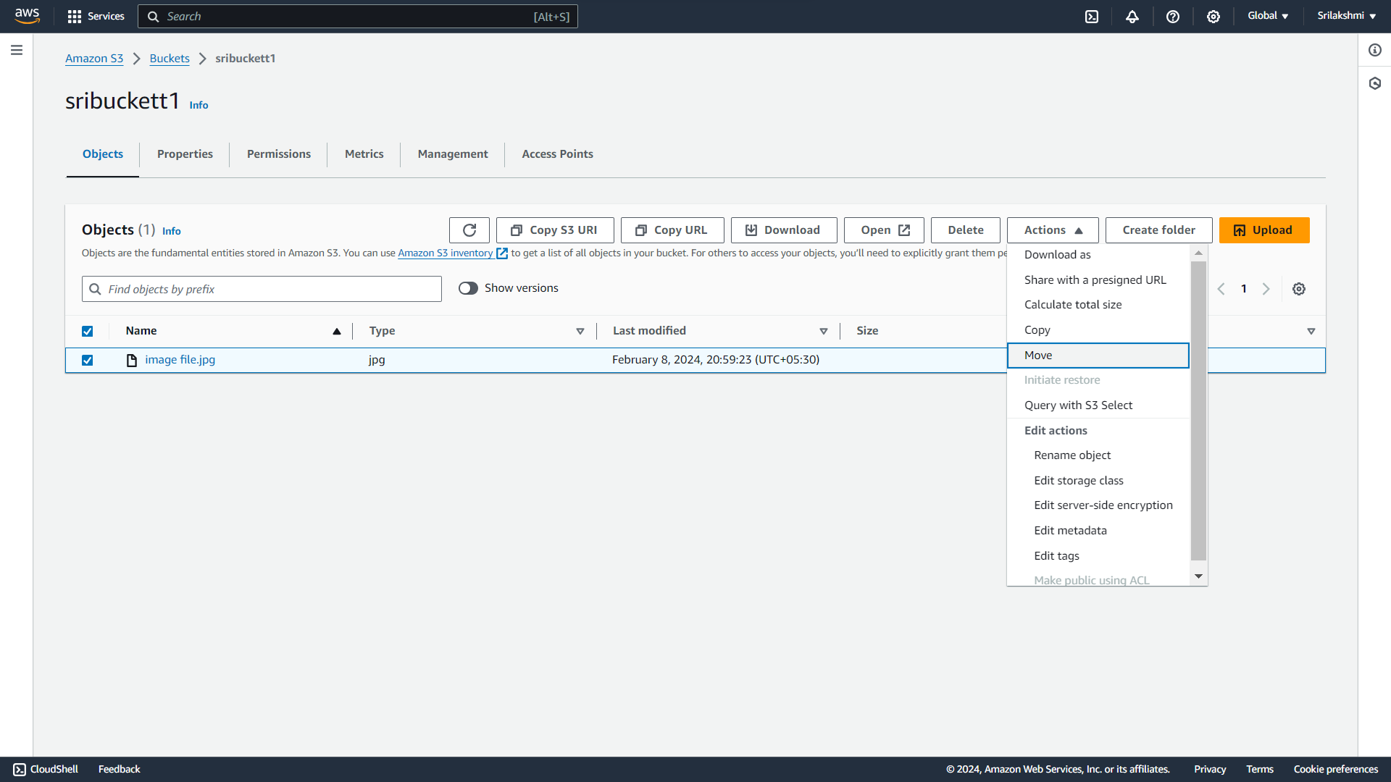

**Give the destination bucket-sribuckett2 and click on move**

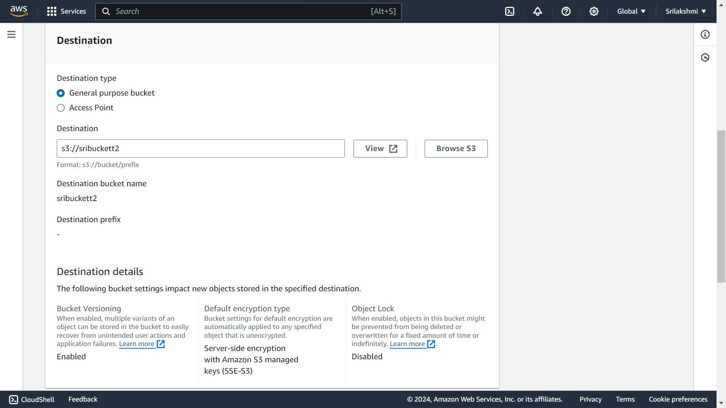

**The file moved successfully from 1st S3 bucket to 2nd S3 bucket**

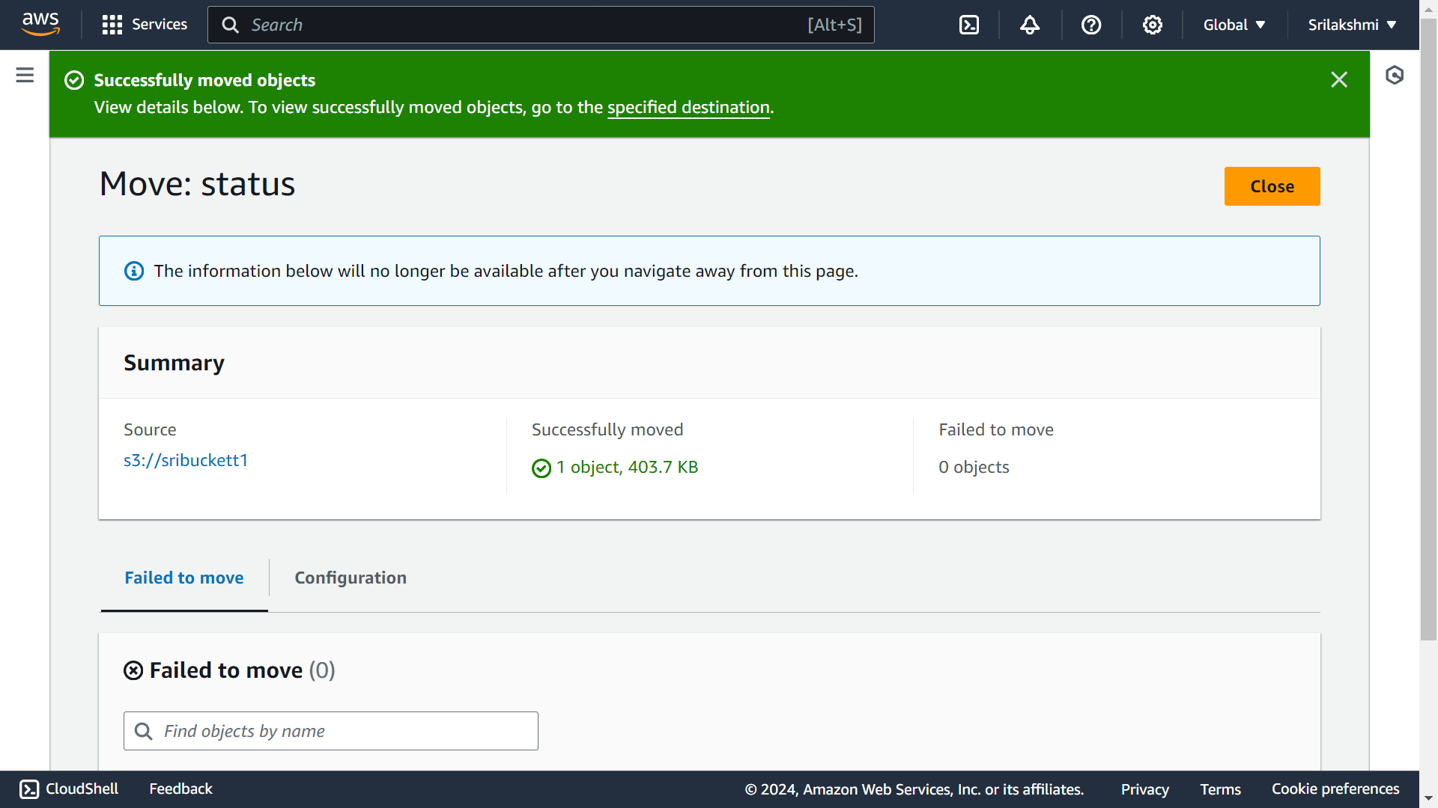

**Now go to destination bucket-sribuckett2 then the file which we moved file will be appear here**

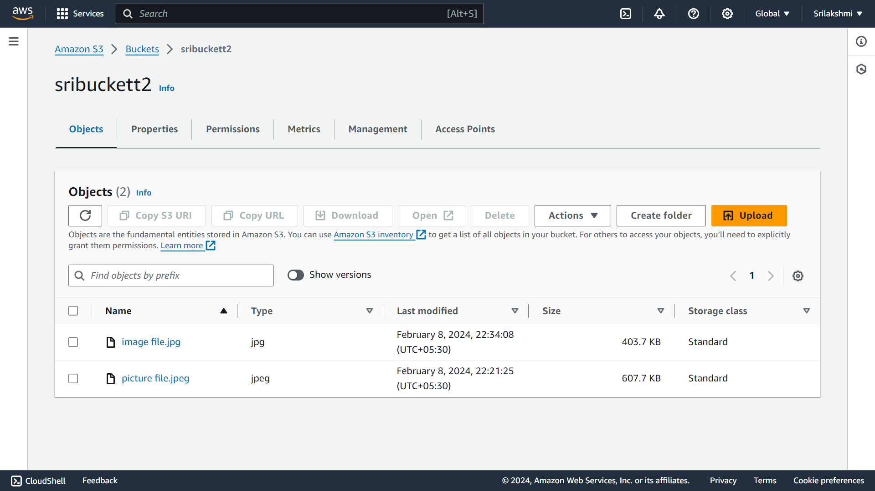

**The moved file will be automatically deleted from the 1st bucket**



**Now Select the 2st S3 bucket-sribuckett2 uploaded file and go to actions and click on move option** 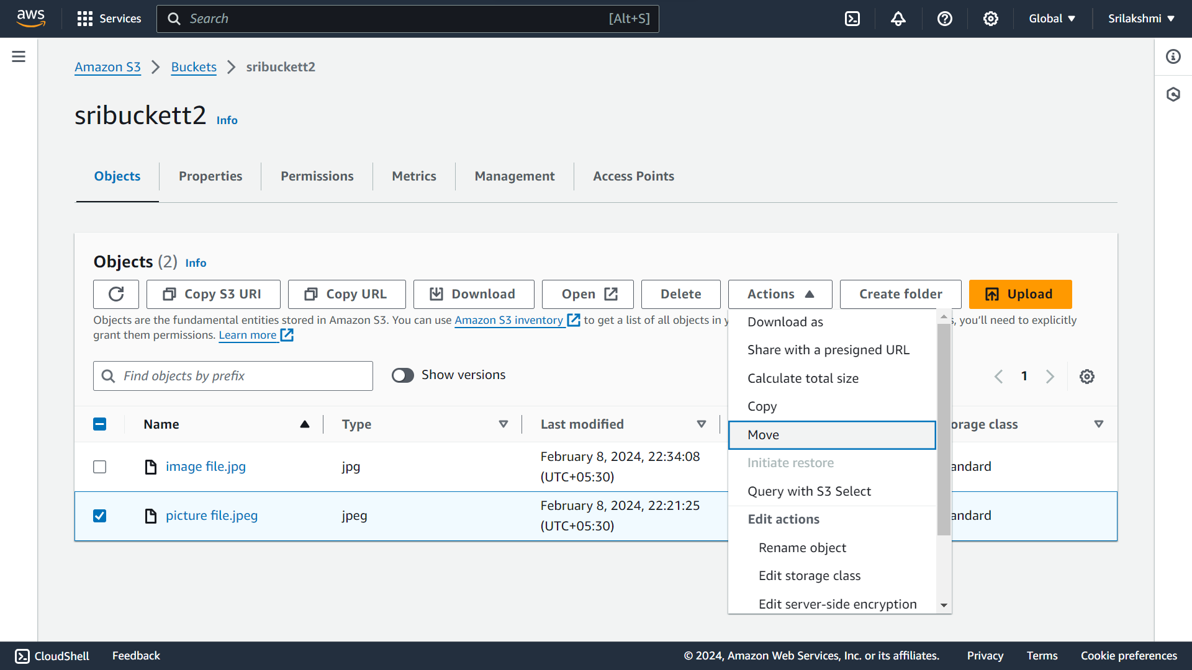

**Give the destination bucket-sribuckett1 and click on move**

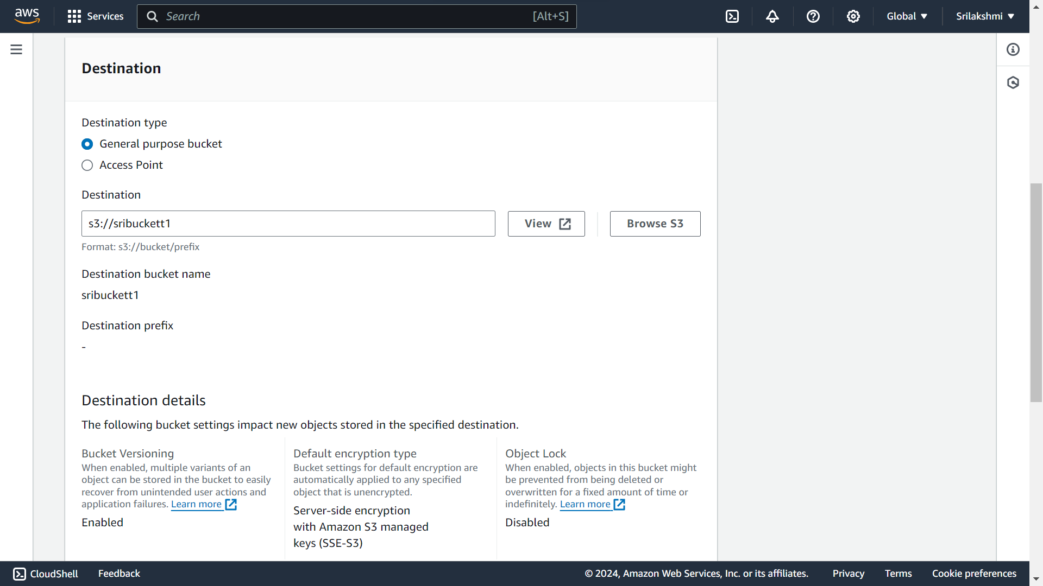

**Now the file moved successfully from 2nd S3 bucket to 1st S3 bucket**

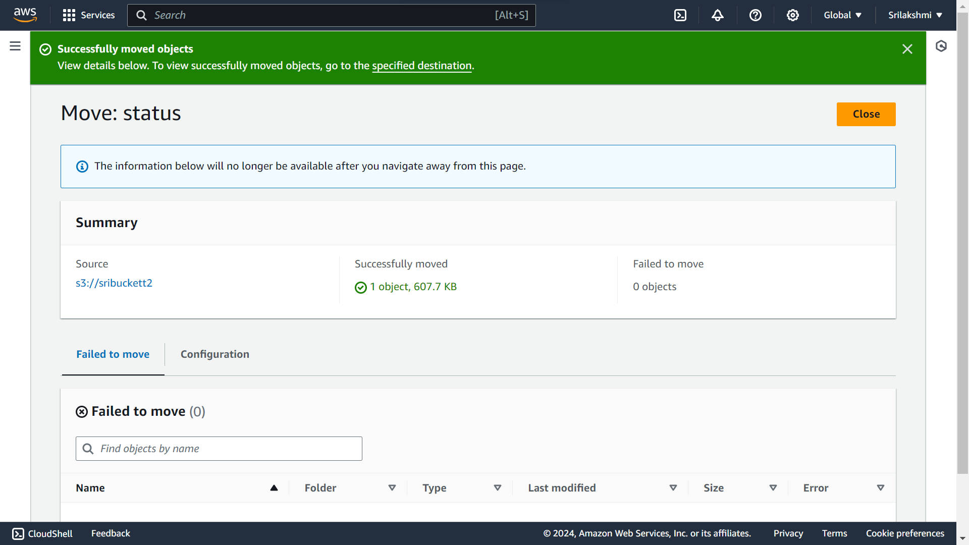

**Now go to destination bucket-sribuckett1 then the file which we moved file will be appear here**

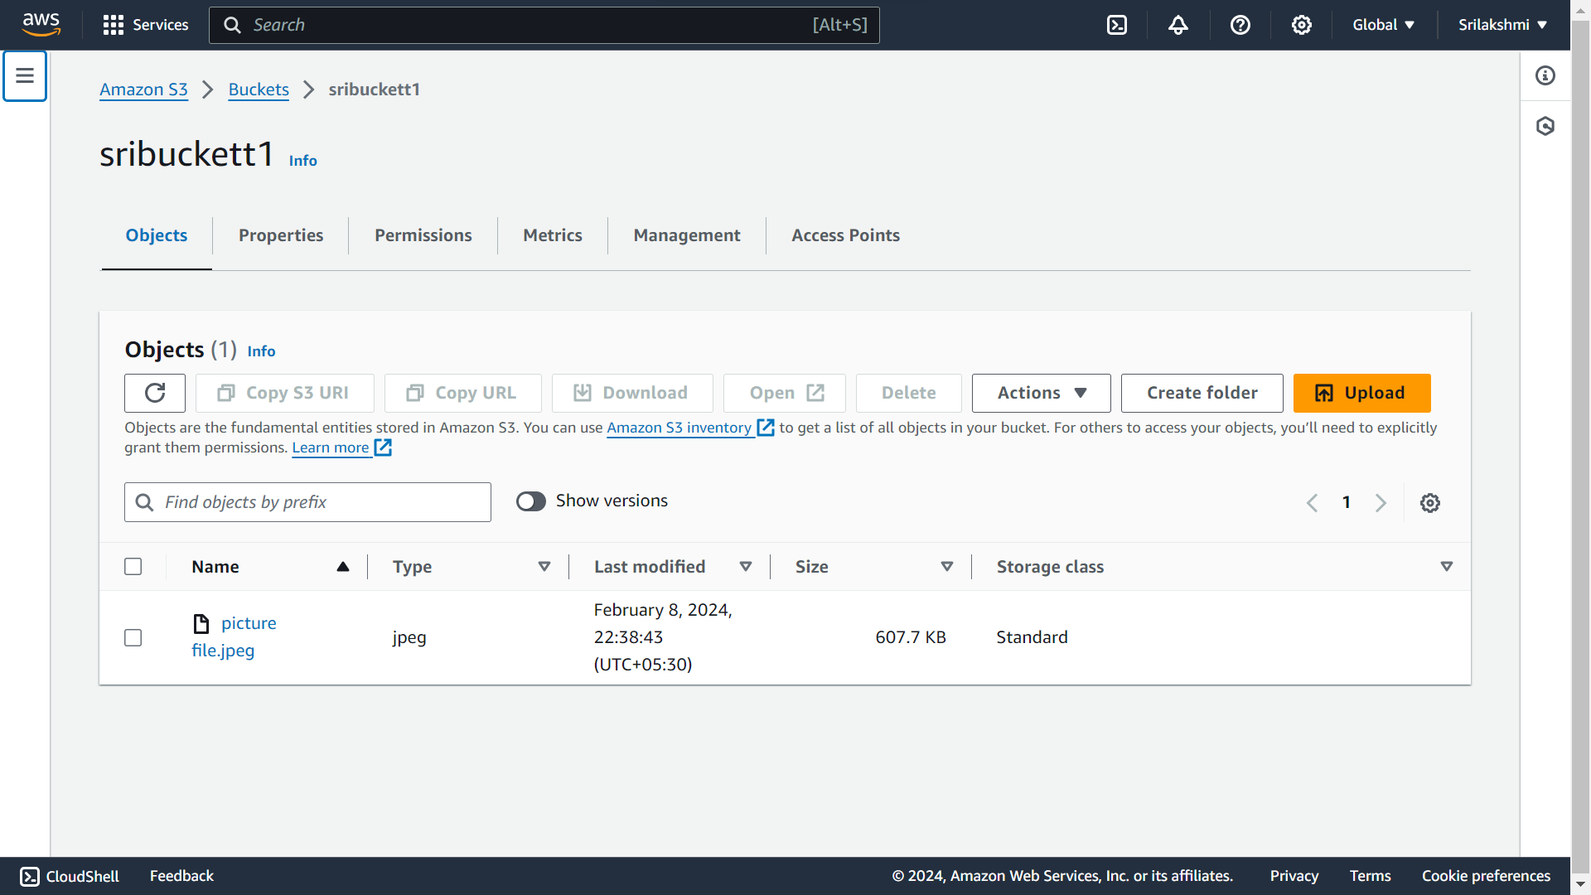

**The moved file will be automatically deleted from the 2st bucket**

